BDD Specflow in .Net Core 3.1
BDD bridges the gap between QA/BA/Developer/Stake holder
There are many tools available to support BDD , some most famous tools are
Cucumber – many languages
Jbehave – Java / Nbehave C#
SpecFlow – C#

But all the above tools has one language in common – which is Gherkin

Gherkin

It is a business readable , domain specific language which will let anybody to understand the software behavior easily
Gherkin has very few syntax which make the parser to behave based on the structure
The syntax of Gherkin are very simple and are pretty readable as plain text

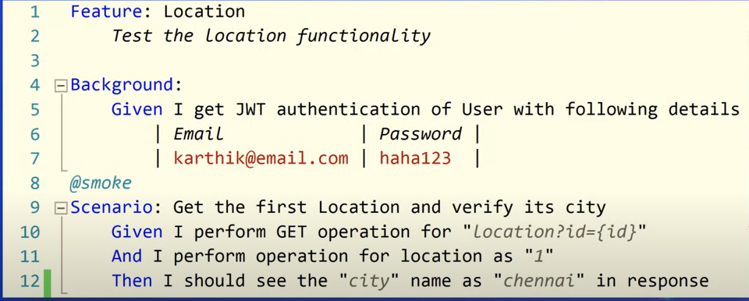

Specflow also support .Net 2.0 standard , which mean , it supports .Net Core 3.1 out of box

NUnit .net core project

Install Specflow for VisualStudio 2019 - Extention

NUnit 3 Test Adapter

Within the project create folder Feature and Steps

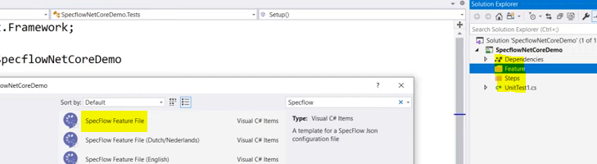
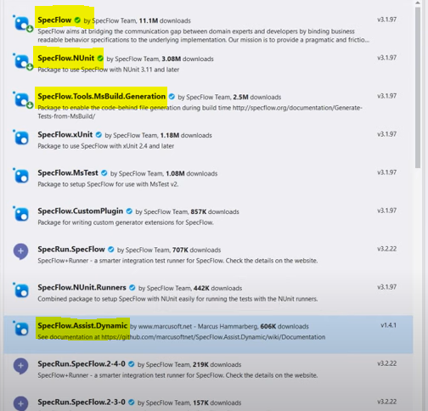
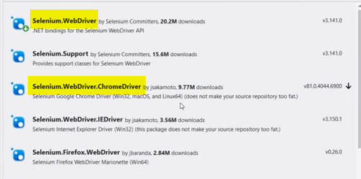

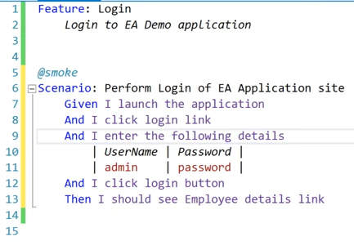
Click on the above and say generate step definitions
Selenium
